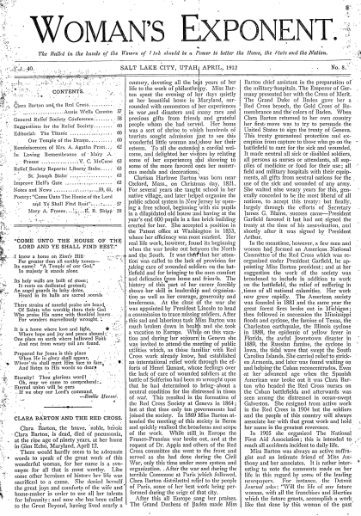
The Woman’s Exponent was published from 1872 to 1914 in Salt Lake City and included reports about local and national suffrage meetings and conferences and editorials about women’s rights were frequently published. Louise Lula Greene was the newspaper’s first editor. Emmeline B. Wells served as associate editor starting with the Exponent’s first edition, then took over full editorial duties with Green’s departure in July 1877. This edition’s masthead reads “The Ballot in the Hands of the Women of Utah should be a Power to better the Home, the State and the Nation.” Courtesy of BYU Special Collections.
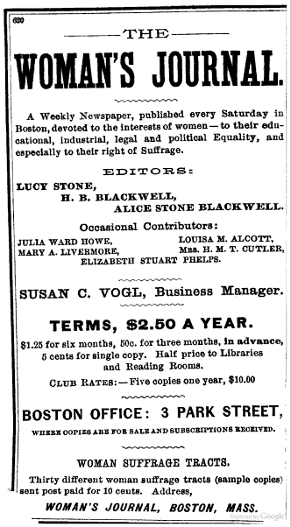
An 1897 advertisement for the Woman’s Journal. The newspaper was published from 1870-1931. It was the official newspaper of the National American Woman Suffrage Association until 1920, when the organization was reformed as the League of Women Voters.
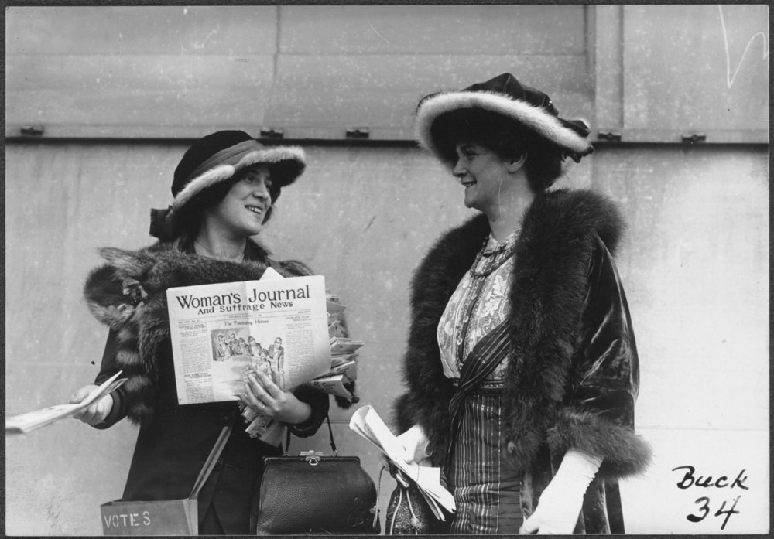
Suffragist Margaret Foley (right) and an unidentified woman distributing copies of the Woman’s Journal on November 29, 1913. Courtesy of Library of Congress.
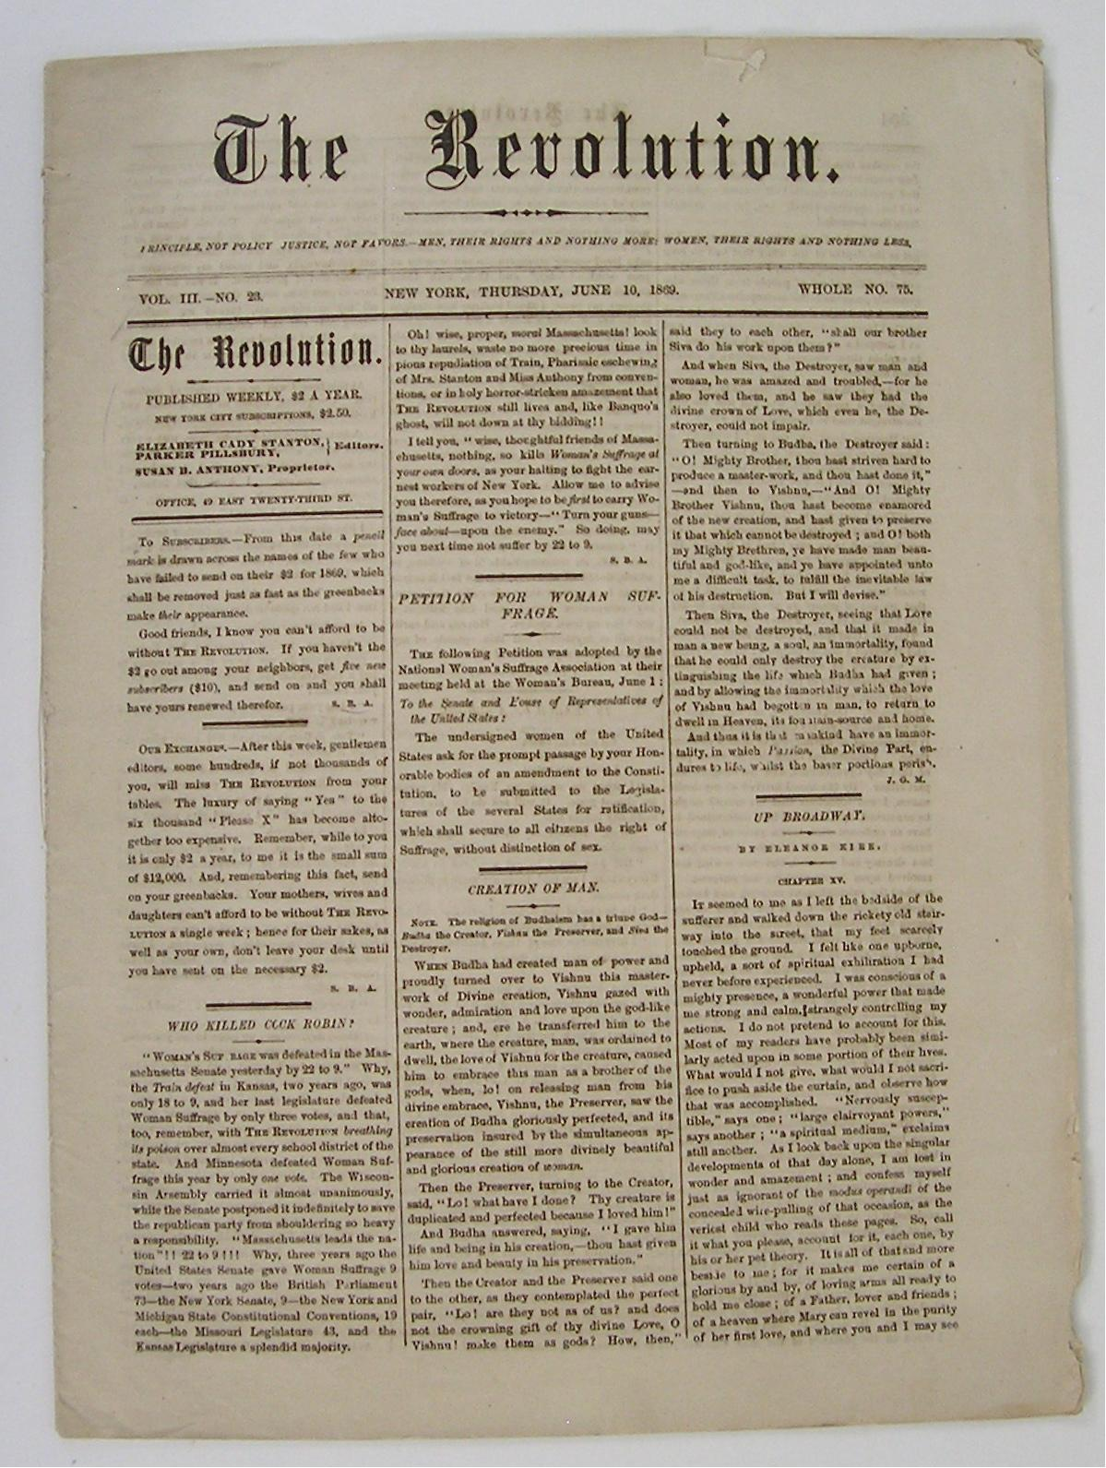
The Revolution ran from 1868-1872 and was started by Susan B. Anthony and Elizabeth Cady Stanton and served as the official newspaper of the National Woman Suffrage Association (NWSA). The paper dealt with not only suffrage but of other issues of interest to women such as divorce laws, the disparity of wages between men and women, and the church’s attitude towards various aspects of women’s rights. The paper was controversial, especially since its major funder, George Francis Train, was a well-known slavery supporter. Photo courtesy of “Woman Suffrage Memorabilia” http://womansuffragememorabilia.com/woman-suffrage-memorabilia/suffrage-journals/
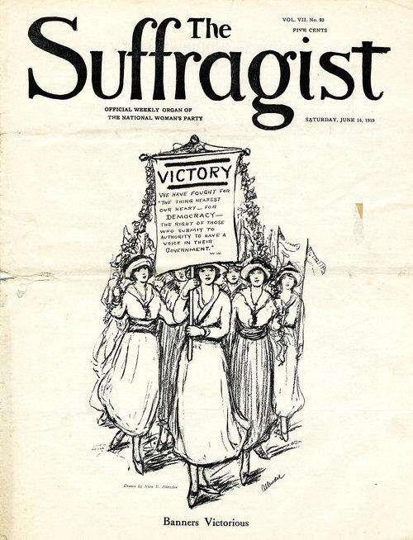
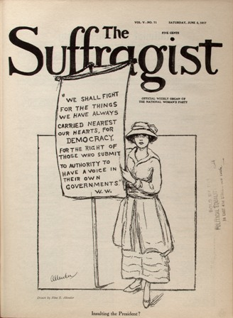
The Suffragist was the official newspaper of the Congressional Union for Woman Suffrage that later became the National Woman’s Party. It was published from 1913-1954. Its focus was to lead the charge for a Federal Suffrage Amendment and its later covers featured cartoons by Nina Allender (as seen here). The Suffragist ceased publication after the passage of the Federal Amendment in 1920. It became several years later into a similar publication called Equal Rights that was started in conjunction with Alice Paul’s work on an Equal Rights Amendment to the Constitution. The top cover from June 1917 features The Silent Sentinels protest outside of the White House. The bottom features the cover from June 14, 1919, just after the 19th Amendment was passed by U.S. Congress. Courtesy of the National Woman’s Party.

