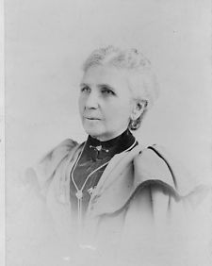

|  |  |  |
| --- | --- | --- |
| **Susan B. Anthony** | **Frederick Douglass** | **Emmeline B. Wells** |
|  |  |  |