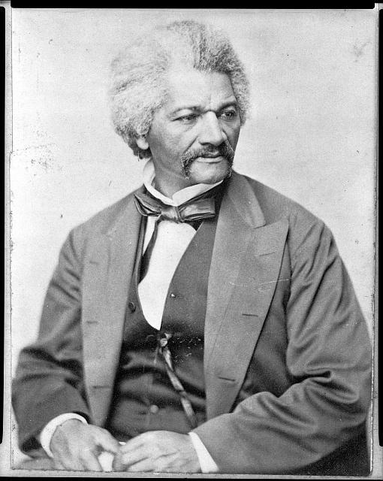
Frederick Douglass was an escaped slave who became a prominent leader in the abolitionist movement because of his skills as an anti-slavery speaker and writer. He was the only African American to attend the Seneca Falls Convention in 1848, and his persuasive arguments in favor of women’s suffrage were critical to convincing the delegates to pass Elizabeth Cady Stanton’s suffrage resolution. Douglass published The North Star, an abolitionist newspaper with the motto “Right is of no sex – Truth is of no color – God is the Father of us all.” This editorial on “The Rights of Women” reported on the women’s rights convention and argued that women were entitled to equal rights, including the right of suffrage.

The Rights of Women
By Frederick Douglass
In The North Star, Rochester, July 28, 1848

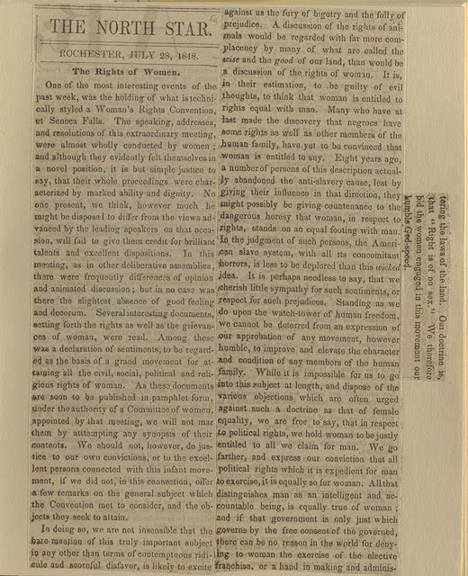
One of the most interesting events of the past week, was the holding of what is technically styled a Woman's Rights Convention at Seneca Falls. The speaking, addresses, and resolutions of this extraordinary meeting were almost wholly conducted by women; and although they evidently felt themselves in a novel position, it is but simple justice to say that their whole proceedings were characterized by marked ability and dignity...In this meeting, as in other deliberative assemblies, there were frequent differences of opinion and animated discussion; but in no case was there the slightest absence of good feeling and decorum. Several interesting documents setting forth the rights as well as the grievances of women were read. Among these was a Declaration of Sentiments, to be regarded as the basis of a grand movement for attaining the civil, social, political, and religious rights of women... A discussion of the rights of animals would be regarded with far more complacency by many of what are called the wise and the good of our land, than would be a discussion of the rights of women. It is, in their estimation, to be guilty of evil thoughts, to think that a woman is entitled to equal rights with man. Many who have at last made the discovery that the negroes have some rights as well as other members of the human family, have yet to be convinced that women are entitled to any. Eight years ago a number of persons of this description actually abandoned the anti-slavery cause, lest by giving their influence in that direction, they might possibly be giving countenance to the dangerous heresy that woman, in respect to rights, stands on an equal footing with man. In the judgment of such persons, the American slave system, with all its concomitant horrors, is less to be deplored than this wicked idea. It is perhaps needless to say, that we cherish little sympathy for such prejudices. Standing as we do upon the watch-tower of human freedom, we cannot be deterred from an expression of our approbation of any movement, however humble, to improve and elevate the character of any members of the human family...we hold woman to be justly entitled to all we claim for man. We go farther, and express our conviction that all political rights that it is expedient for man to exercise, it is equally so for woman. All that distinguishes man as an intelligent and accountable being, is equally true of woman; and if that government only is just which governs by the free consent of the governed, there can be no reason in the world for denying to woman the exercise of the elective franchise, or a hand in making and administering the laws of the land. Our doctrine is that "right is of no sex." We therefore bid the women engaged in this movement our humble Godspeed.

Photo: 1) Frederick Douglass in 1870. 2) Original copy of The North Star editorial. Courtesy of Library of Congress.

