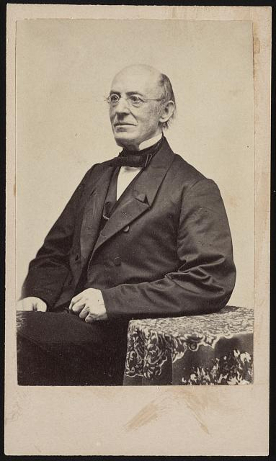
William Lloyd Garrison was one of the most influential and prominent abolitionists in the United States. In 1831 he began publishing the abolitionist newspaper The Liberator, and in 1833 he helped organize the American Anti-Slavery Society. He became a prominent voice for the women’s suffrage movement and women’s rights movement beginning in the 1830s. In this February 14, 1854 speech, delivered to the Anti-Slavery Society in New York, Garrison demanded the “immediate and unconditional emancipation” of slaves.

Excerpts from “No Compromise with the Evil of Slavery” (1854)
By William Lloyd Garrison

I am a believer in that portion of the Declaration of American Independence in which it is set forth, as among self-evident truths, "that all men are created equal; that they are endowed by their Creator with certain inalienable rights; that among these are life, liberty, and the pursuit of happiness." Hence, I am an abolitionist. Hence, I cannot but regard oppression in every form and most of all, that which turns a man into a thing with indignation and abhorrence. Not to cherish these feelings would be recreancy to principle...Convince me that one man may rightfully make another man his slave, and I will no longer subscribe to the Declaration of Independence. Convince me that liberty is not the inalienable birthright of every human being, of whatever complexion or clime, and I will give that instrument to the consuming fire. I do not know how to espouse freedom and slavery together...My crime is that I will not go with the multitude to do evil…
The abolitionism which I advocate is as absolute as the law of God, and as unyielding as his throne. It admits of no compromise. Every slave is a stolen man; every slaveholder is a man stealer. By no precedent, no example, no law, no compact, no purchase, no bequest, no inheritance, no combination of circumstances, is slaveholding right or justifiable...Such, at least, is the verdict of my own soul, on the supposition that I am to be the slave; that my wife is to be sold from me for the vilest purposes; that my children are to be torn from my arms, and disposed of to the highest bidder, like sheep in the market. And who am I but a man? What right have I to be free, that another man cannot prove himself to possess by nature? Who or what are my wife and children, that they should not be herded with four-footed beasts, as well as others thus sacredly related?
If the slaves are not men; if they do not possess human instincts, passions, faculties, and powers; if they are below accountability, and devoid of reason; if for them there is no hope of immortality, no God, no heaven, no hell; if, in short, they are what the slave code declares them to be, rightly "deemed, sold, taken, reputed and adjudged in law to be chattels personal in the hands of their owners and possessors, and their executors, administrators and assigns, to all intents, constructions, and purposes whatsoever"; then, undeniably, I am mad, and can no longer discriminate between a man and a beast...
But, if they are men; if they are to run the same career of immortality with ourselves; if the same law of God is over them as over all others; if they have souls to be saved or lost...then, when I claim for them all that we claim for ourselves, because we are created in the image of God, I am guilty of no extravagance...and demand their immediate and unconditional emancipation...
The reason why the South rules, and the North falls prostrate in servile terror, is simply this: with the South, the preservation of slavery is paramount to all other considerations...With the North, the preservation of the Union is placed above all other things…
What then is to be done? Friends of the slave, the question is not whether by our efforts we can abolish slavery, speedily or remotely for duty is ours, the result is with God; but whether we will go with the multitude to do evil, sell our birthright for a mess of pottage, cease to cry aloud and spare not...Let us stand in our lot, "and having done all, to stand." At least, a remnant shall be saved. Living or dying, defeated or victorious, be it ours to exclaim, "No compromise with slavery! Liberty for each, for all, forever! Man above all institutions! The supremacy of God over the whole earth!"

Photo: William Lloyd Garrison, 1870. Courtesy of Library of Congress.

