Silent Sentinels and Hunger Strikes (1917-1919)

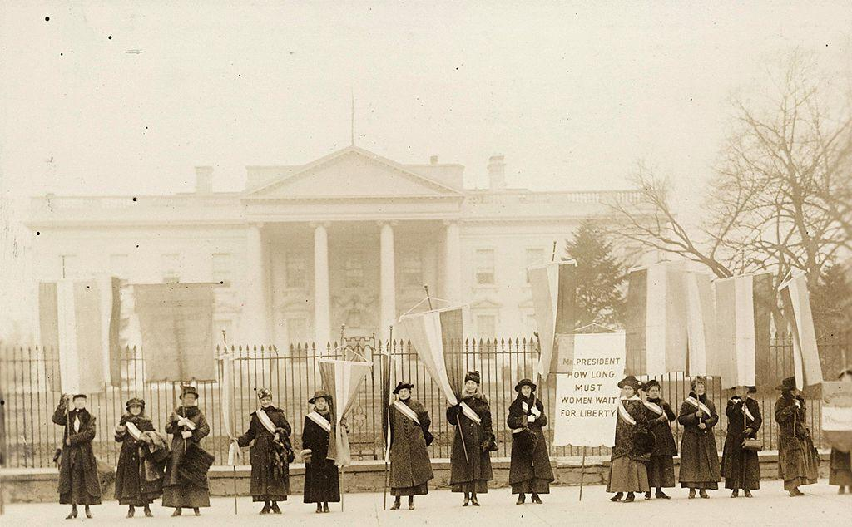
National Woman’s Party picketing the White House in 1917. Courtesy of Library of Congress.

On January 10, 1917, Alice Paul and a dozen women from the National Woman’s Party were first people to ever picket the White House. For nearly two and a half years, almost 2000 women engaged in picketing outside the White House six days a week until June 4, 1919, when the suffrage amendment finally passed both the U.S. Senate and House of Representatives. Calling themselves the “Silent Sentinels,” the women carried banners with messages such as: “Mr. President - How Long Must Women Wait For Liberty?” and “Mr. President – What Will You Do For Woman Suffrage?” In the wake of World War I, the banners accused President Wilson of hypocrisy for fighting for world democracy while leaving American women without rights. One year after the picketing began, President Wilson announced his support for the suffrage amendment. The suffragists continued their protest and were harassed, arrested, jailed, and even force fed when they went on hunger strikes in the Occoquan Workhouse prison. On the night of November 14, 1917, known as the “Night of Terror,” the prison superintendent ordered forty guards to brutalize the imprisoned suffragists, who were chained, beaten, choked, and tortured. Their mistreatment angered many Americans and created more support for the suffrage movement. By the time the suffrage amendment passed, a U.S. Court of Appeals had also cleared the suffragists of charges for their civil disobedience, creating important legal precedents that paved the way for generations of protestors.

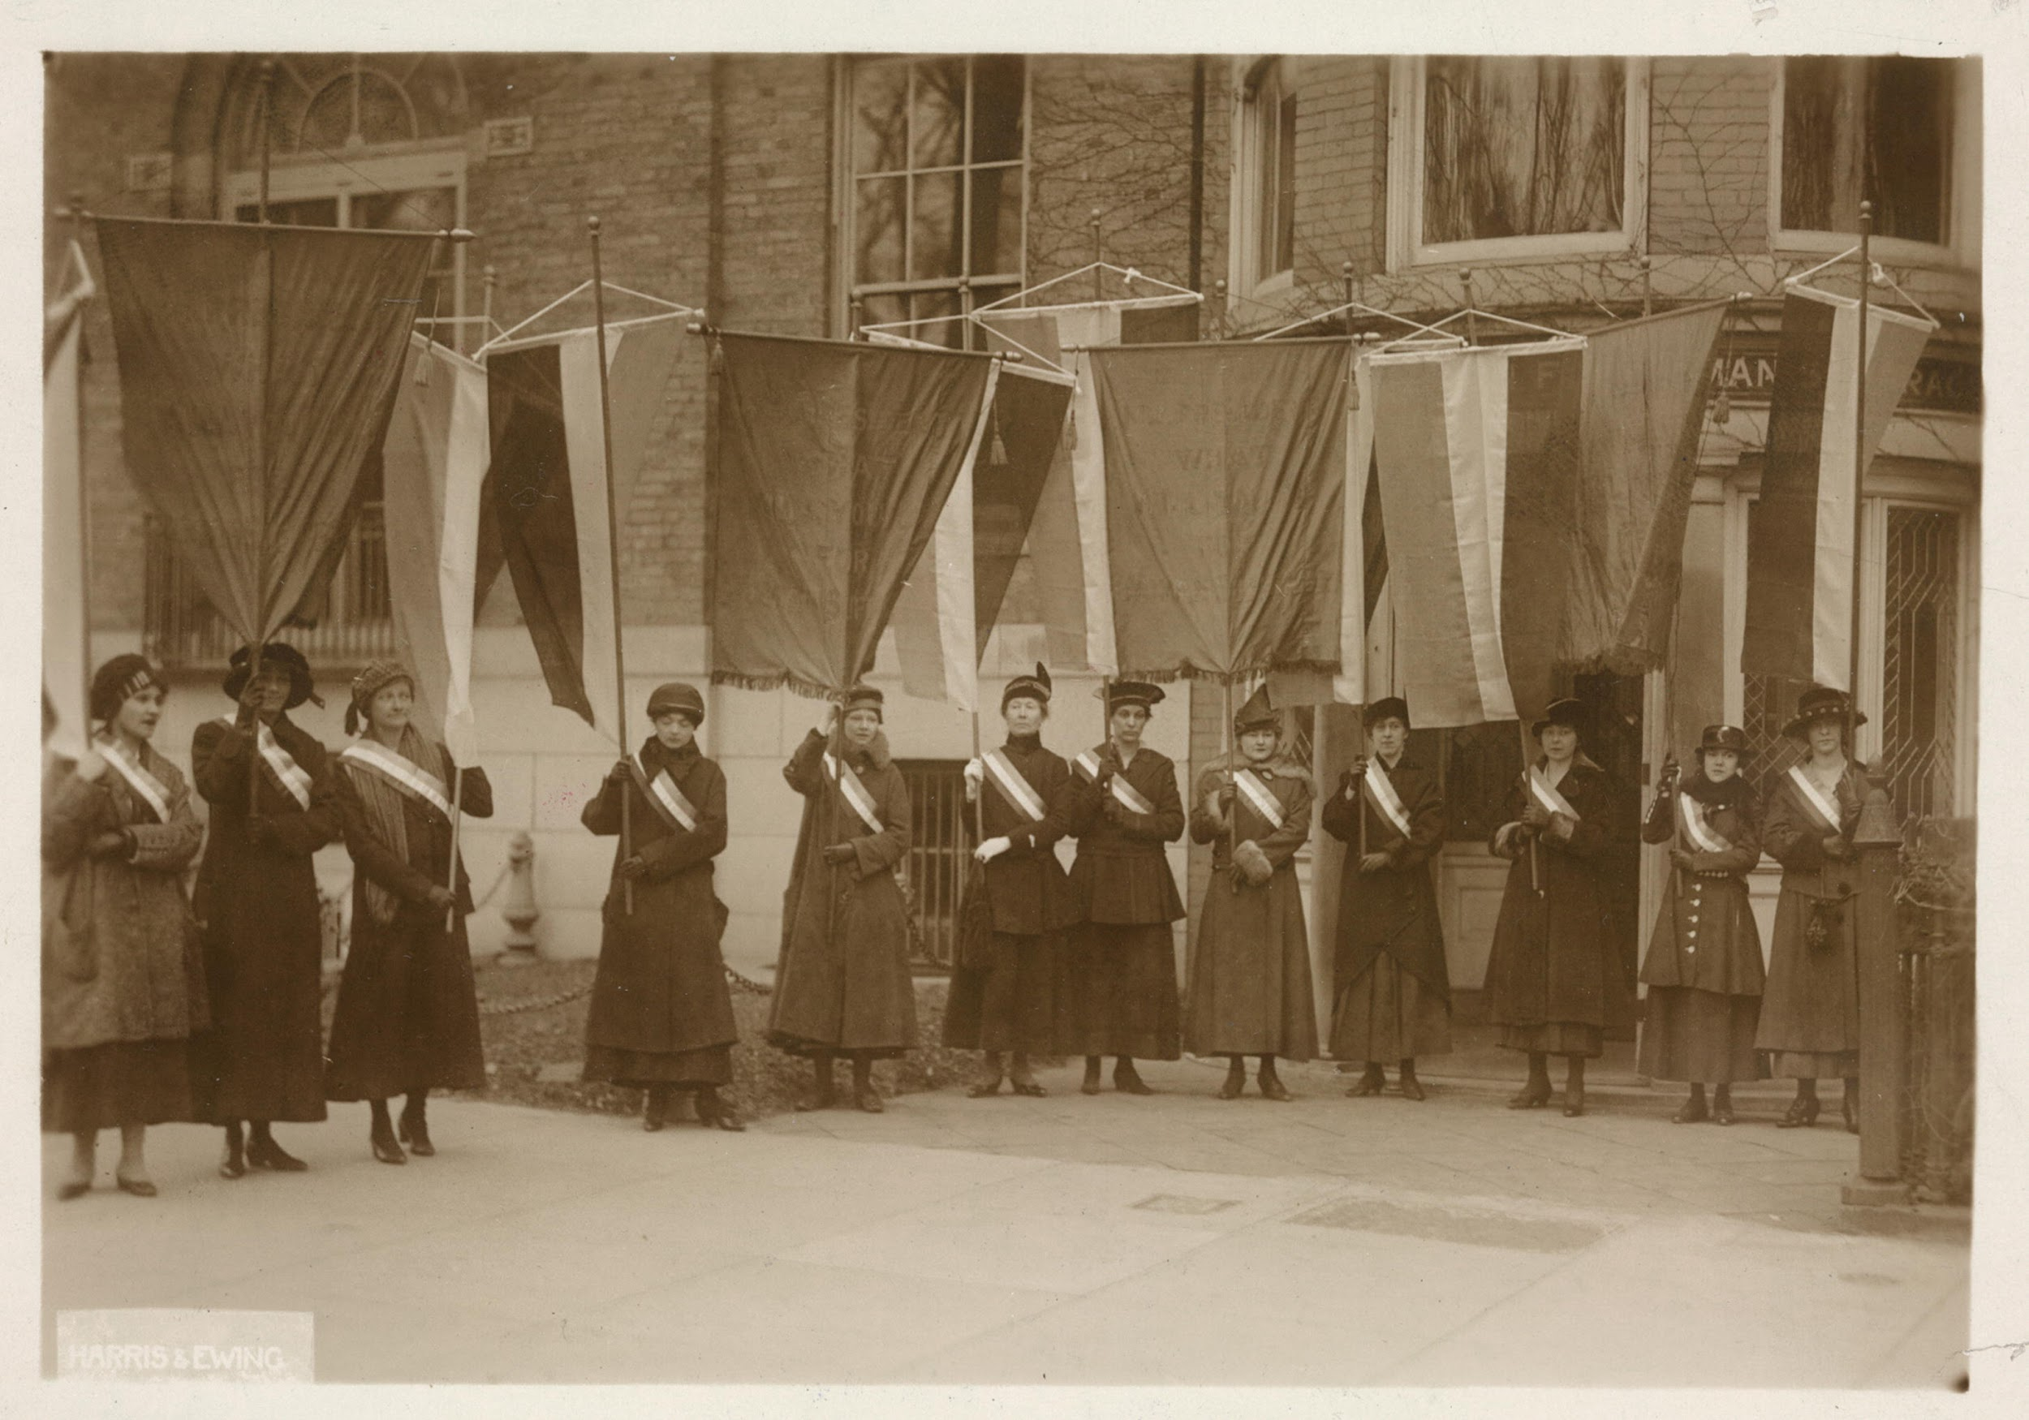
The very first picket line on January 10, 1917. Courtesy of Library of Congress.

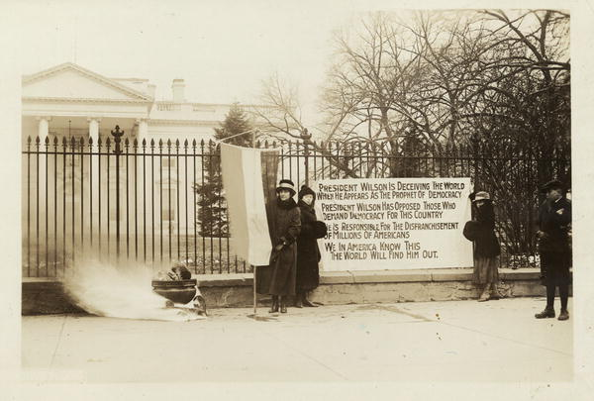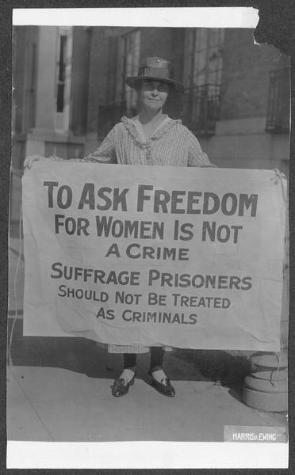
(left) White House Picketers, January 1919. (right) Mary Winsor of Pennsylvania, 1917. Courtesy of Library of Congress.

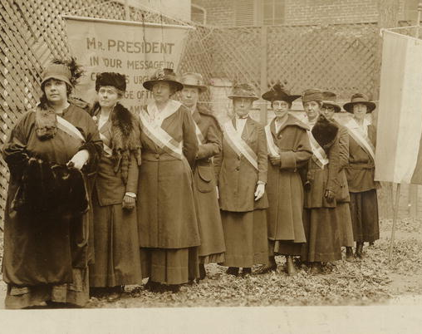
Some of the women on the picket line of Nov. 10, 1917. Left to right: Mrs. Catherine Martinette, Eagle Grove, Iowa. Mrs. William Kent, Kentfield, California. Miss Mary Bartlett Dixon, Easton, Md. Ellen Lovern Robertson, Salt Lake City, Utah. Miss Cora Week, New York City. Miss Amy Ju[e]ngling, Buffalo, N.Y. Courtesy of Library of Congress.
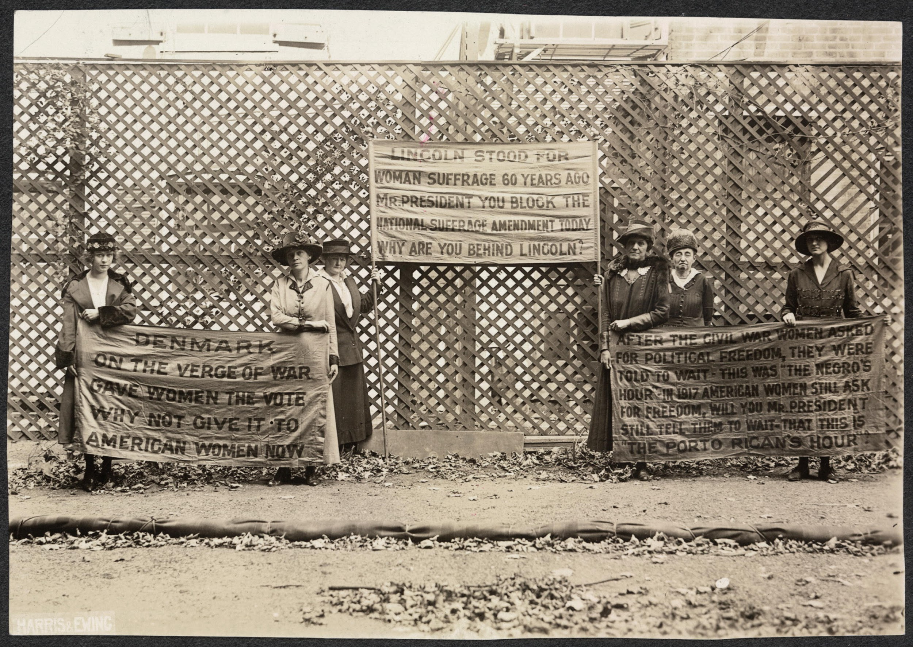
Picketers on President Lincoln’s birthday. Courtesy of Library of Congress.

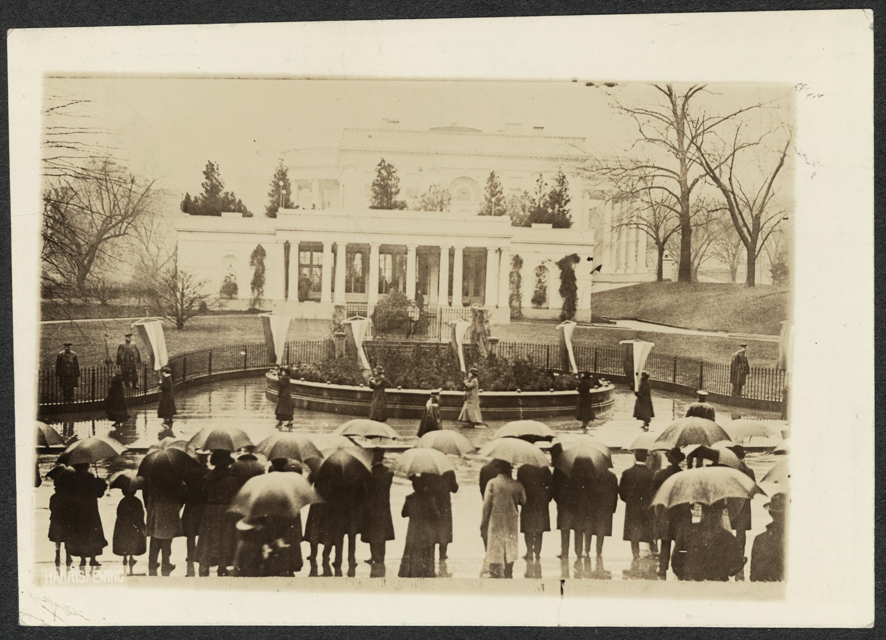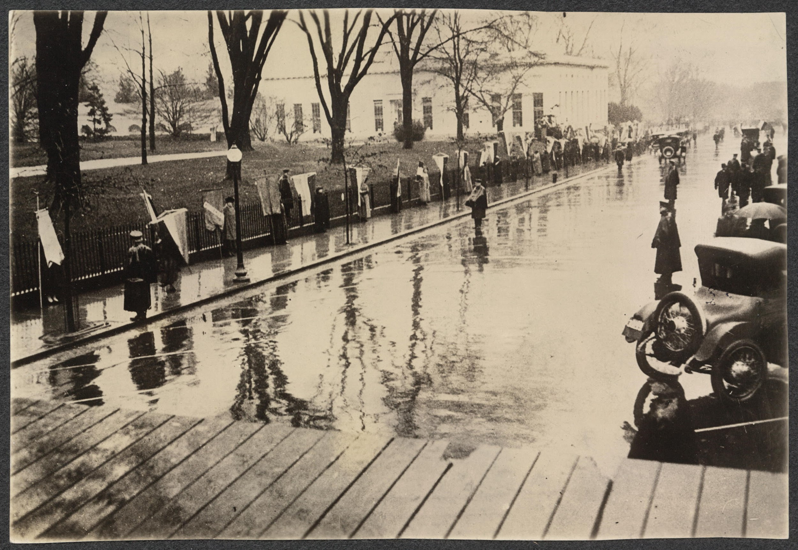
Picketing the White House on March 4, 1917. Courtesy of Library of Congress.
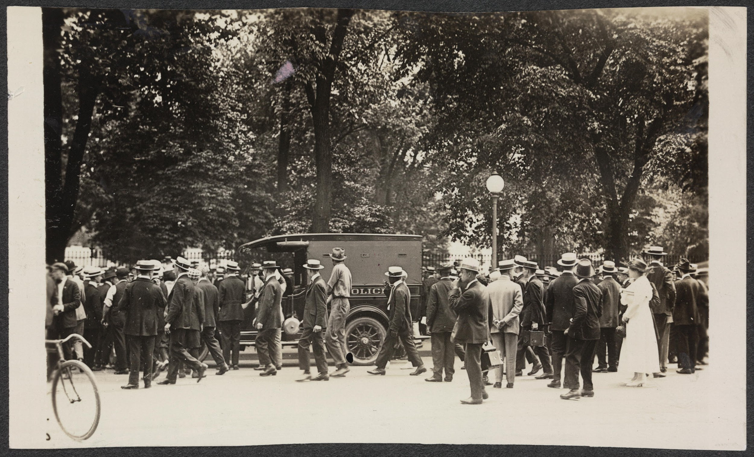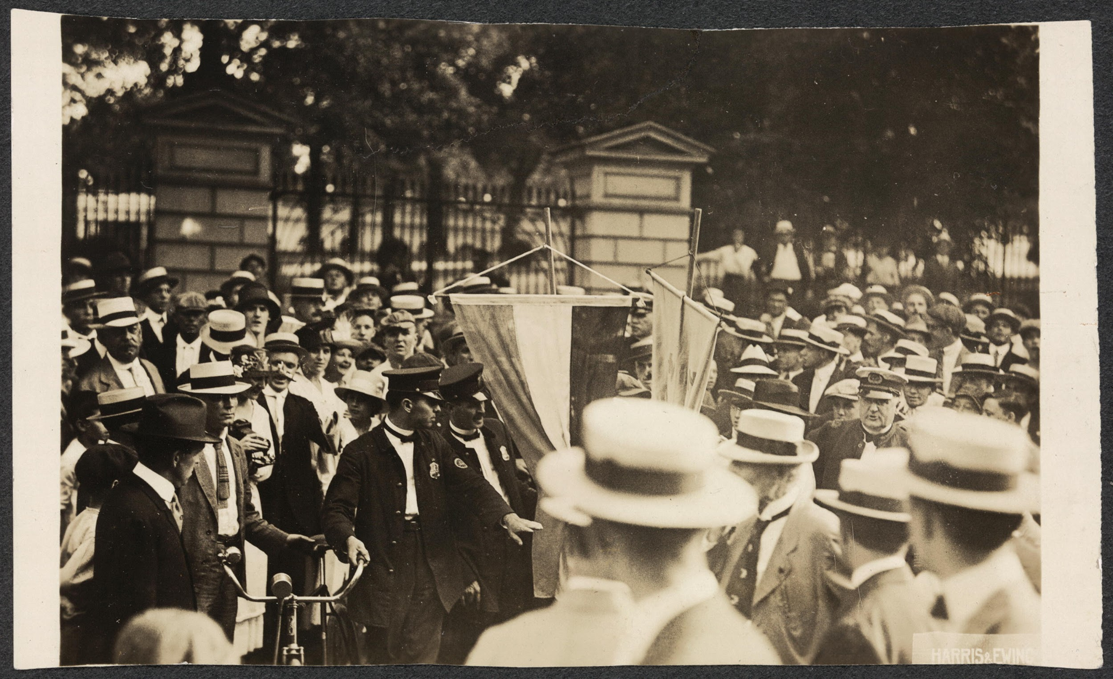
Police arresting picketers. Courtesy of Library of Congress.

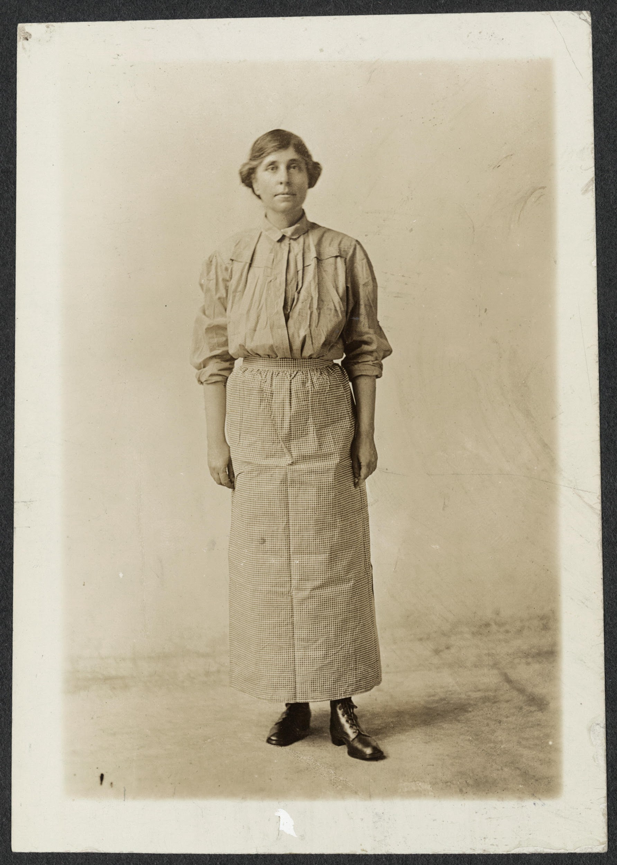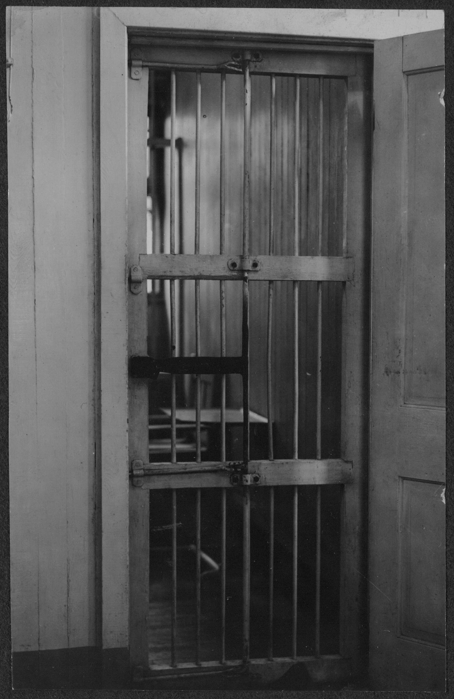

(left) Abby Scott Baker in prison dress in 1919. (right) Cell at Occoquan Workhouse. Courtesy of Library of Congress.

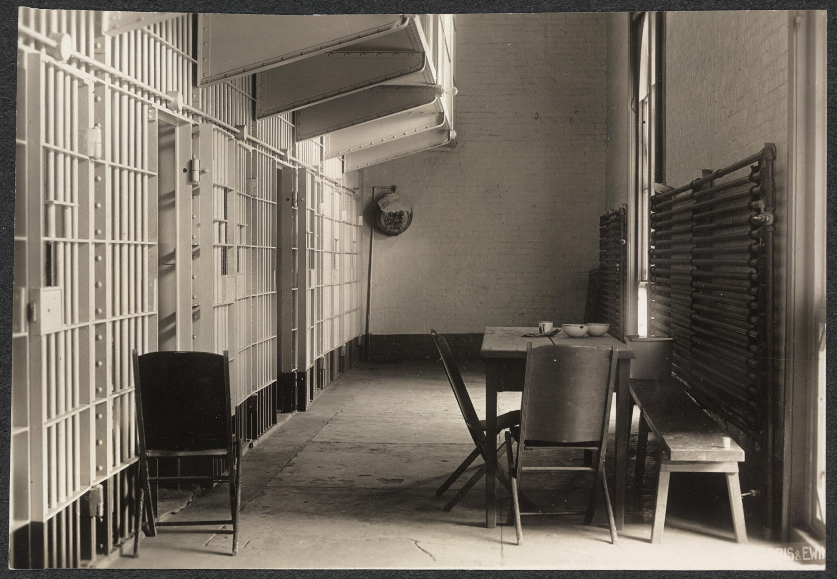
Cell block where suffragists were held in D.C. prison. Courtesy of Library of Congress.

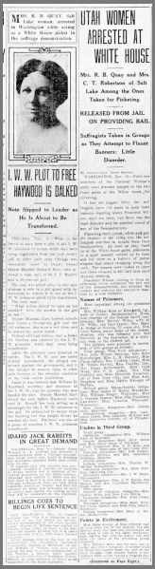
From The Salt Lake Tribune, November 11, 1917

UTAH WOMEN ARRESTED AT WHITE HOUSE
Mrs. R. B. Quay and Mrs. C. T. Robertson of Salt Lake Among the Ones Taken for Picketing.

RELEASED FROM JAIL ON PROVIDING BAIL
Suffragists Taken in Groups as They Attempt to Flaunt Banners; Little Disorder.

By International News Service.

WASHINGTON, Nov. 10--Forty-one members of the National Woman’s party were arrested tonight at the two front gates of the White House for picketing.
It was the biggest drive the suffragists have yet made to keep their banners standing where President Wilson could see them, but there was the least disorder and the smallest crowds of any of the demonstrations.
Flaunting their their yellow, white, and purple banners to the dying sun, the suffragists marched in squads from their headquarters. As soon as they lined up at the White House gates, policemen in a quiet manner walked up to them and led them to a battery of patrol wagons that stood chugging along the curb. The women were rushed to court and there released in $25 bail each until Monday morning.
President Wilson, coming in from an afternoon drive, witnessed the tail end of the demonstration, but avoided the crowds and entered the executive mansion by a side entrance.

Names of Prisoners.
Most important among the prisoners were:
Mrs. William Kent of Kentfield, Cal., wife of former Representative Kent, now member of the federal tariff commission; Mrs. Harvey Wiley, wife of Dr. Wiley, food expert; Mrs. Mary A. Nolan of Florida, 73 years old; Mrs. Lucy Burns, major domo of the demonstration, who was released only last Saturday at the expiration of a sixty-day term in the district jail.
The pickets were arrested in succession of five groups as follows:
First group: New York delegation…
Second group: Massachusetts delegation…New Jersey delegation...Pennsylvania delegation…

Utahns in Third Group.
Third group: California delegation...Oregon delegation...Utah delegation--Mrs. R. B. Quay and Mrs. C. T. Robertson of Salt Lake City. Colorado delegation…
Fourth group: Indiana delegation...Oklahoma delegation...Minnesota delegation...Iowa delegation.
Fifth group: District of Columbia delegation...Louisiana delegation...Maryland delegation...Florida delegation.

Faints in Excitement.
Miss Mida Sharpe of New Orleans was to have been one of the pickets, but she fainted from the heat and excitement as she stood in line in the party headquarters waiting her turn to march out and take the place of the preceding group arrested.
Mrs. William Kent was the only one to suffer any direct indignity. A soldier tried to wrest her banner from her, and in the brief struggle that ensued before a policeman went to her rescue a rougher element in the hard-pressing crowd showered her with an American variant of billingsgate.
Virtually no other demonstrations accompanied the raid except some jeering form the crowd.
The picketing and the arrest may have been a social affair. It was conducted politely both by the suffragists themselves and the police.
The women were grimfaced at first as they marched from their headquarters near by to one or the other White House gates, but went to the patrol with a smile and no resistance almost at once after they had taken their places flanking the entrances. Their immediate purpose, apparently, was to have themselves arrested, and the police, in almost every instance, made the arrests with a courteous lifting of the cap and an apologetic ? ? ? the pickets to the patrols with as much gallantry as if they were going from the opera to a limousine.

Carried Banners.
The leader of each group carried a huge, yellow suffrage banner bearing the words: “Mr. President, in your message to congress urge the passage of the federal amendment enfranchising women.”
All the others carried the suffrage banners of purple, white, and yellow, and they took the banners with them in the patrol automobile, making a gay procession of it on the way to court, but the bunting flaunting from the front and rear through crowds that cheered, jeered, clapped, and hissed.
At the court each woman was released on a $25 bail for appearance Monday, the bail furnished in every instance by Miss Mary Ingham of Philadelphia, one of the original sixteen White House pickets pardoned by the president, and acting chairman of the Philadelphia branch of the party.
Including the arrests made this afternoon, 135 women have been sent to jail, some of them two or three times, and sixty-six women have served or are serving jail sentences.

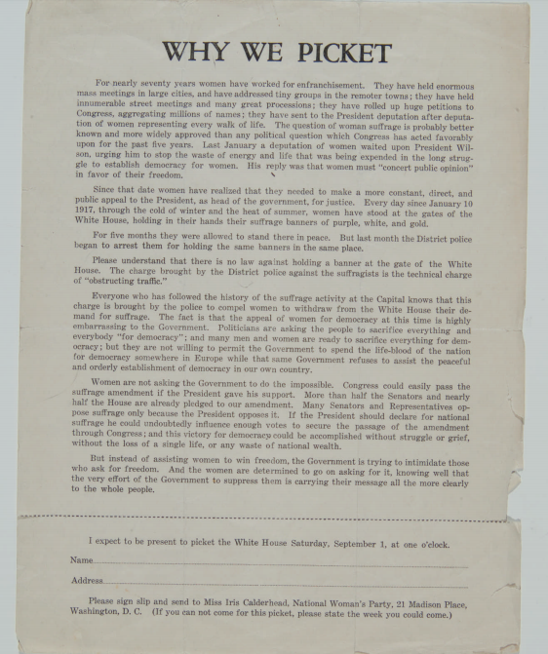
Courtesy of Historical Society of Pennsylvania.

