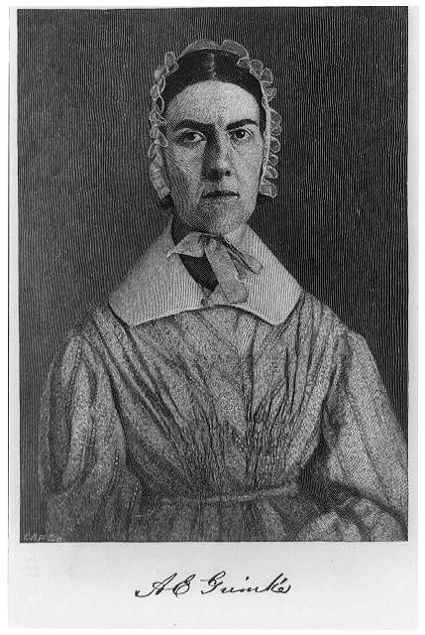
Angelina Grimké gave this speech to the Massachusetts Legislature in February 1838, making her the first woman in the United States to address a legislative body in the new nation. She spoke on behalf of the 20,000 women who signed a petition demanding the immediate end of the slave trade in Washington, D.C., and asserted her political rights as a woman and as a citizen.

***
MR. CHAIRMAN--

...I stand before you as a citizen, on behalf of the 20,000 women of Massachusetts, whose names are enrolled on petitions which have been submitted to the Legislature of which you are the organ. These petitions relate to the great and solemn subject of American slavery-a subject fraught with the deepest interest to this republic, whether we regard it in its political, moral, or religious aspects. And because it is a political subject, it has often been tauntingly said, that woman has nothing to do with it. Are we aliens, because we are women? Are we bereft of citizenship, because we are the mothers, wives, and daughters of a mighty people? Have women no country-no interests staked in public weal-no liabilities in common peril-no partnership in a nation's guilt and shame? Let the history of the world answer these queries. Read the denunciations of Jehovah against the follies and crimes of Israel's daughters. Trace the influence of woman as a courtezan and a mistress in the destinies of nations, both ancient and modern, and see her wielding her power too often to debase and destroy, rather than to elevate and save. It is often said that women rule the world, through their influence over men. If so, then may we well hide our faces in the dust, and cover ourselves with sackcloth and ashes.

It has not been by moral power and intellectual, but through the baser passions of man. This domination of women must be resigned-the sooner the better; in the age which is approaching, she should be something more--she should be a citizen; and this title, which demands an increase of knowledge and of reflection, opens before her a new empire! I hold, Mr. Chairman, that American women have to do with this subject, not only because it is moral and religious, but because it is political, inasmuch as we are citizens of this republic, and as such our honor, happiness, and well being, are bound up in its politics and government and laws.

I stand before you as a southerner, exiled from the land of my birth, by the sound of the lash, and the pitious cry of the slave. I stand before you as a repentant slaveholder. I stand before you as a moral being, endowed with precious and inalienable rights, which are correlative with solemn duties and high responsibilities; and as a moral being I feel that owe it to the suffering slave, and to the deluded master, to my country and the world, to do all that I can to overturn a system of complicated crimes, built up upon the broken hearts and prostrate bodies of my countrymen in chains, and cemented by the blood and sweat and tears of my sisters in bonds ....

