1913 Woman Suffrage Procession

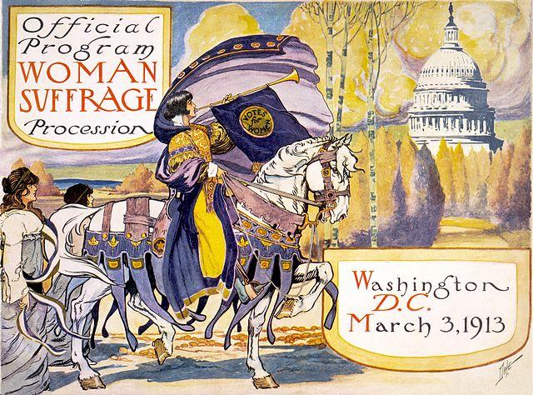
Cover of the Official Program for the Woman Suffrage Procession. Courtesy of Library of Congress.

On March 3, 1913, thousands of suffragists marched down Pennsylvania Avenue in Washington, D.C. as part of a demonstration to demand the right to vote. The Woman Suffrage Procession was the largest suffrage event in United States history, a turning point in the women’s suffrage movement, and a key factor in securing the suffrage amendment a few years later. The parade was organized by Alice Paul, on behalf of the National American Woman Suffrage Association (“NAWSA”), to coincide with the inauguration of newly-elected President Woodrow Wilson to protest the exclusion of women from politics. A large group of “Suffrage Hikers” increased publicity by walking from New York City to Washington, D.C. to participate in the parade. Partway through the parade, marchers encountered crowds blocking their way and harassing the suffragists. Over 200 women required emergency care at local hospitals, and the mistreatment of the marchers by the police and crowds contributed even further to a shift in public opinion in favor of suffrage. Because of the crowds, the parade took six hours to travel from the Capitol to Constitution Hall, but it successfully drew attention to the cause and reinvigorated the suffrage movement. Following the parade, Alice Paul organized the Congressional Union of Women Voters to continue advocating for suffrage through more militant tactics than the more moderate NAWSA was willing to authorize.
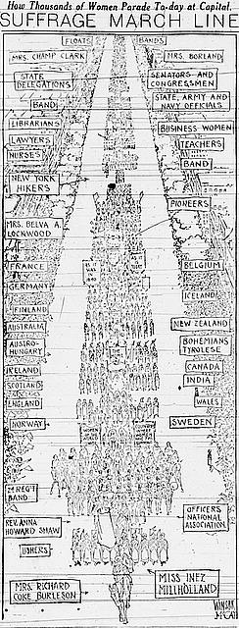
Women marchers organized by country, state, occupation, and organization, led by Miss Inez Milholland and Mrs. Richard Coke Burleson, during the suffrage march, March 3, 1913, Washington, D.C. Courtesy of Library of Congress.
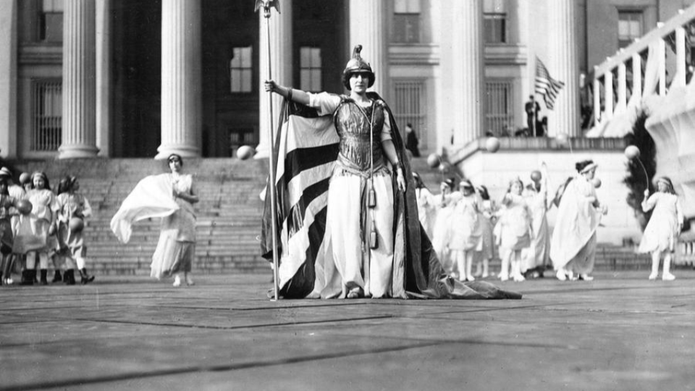
Inez Milholland leading the procession. Courtesy of Library of Congress.

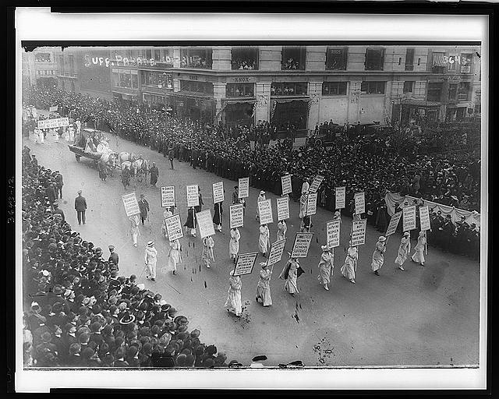
Courtesy of Library of Congress.

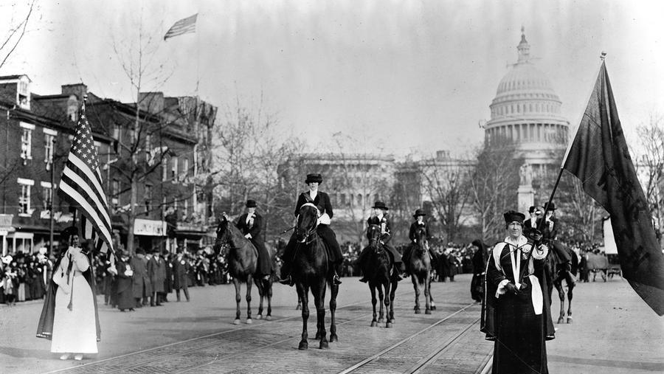
Courtesy of Library of Congress.
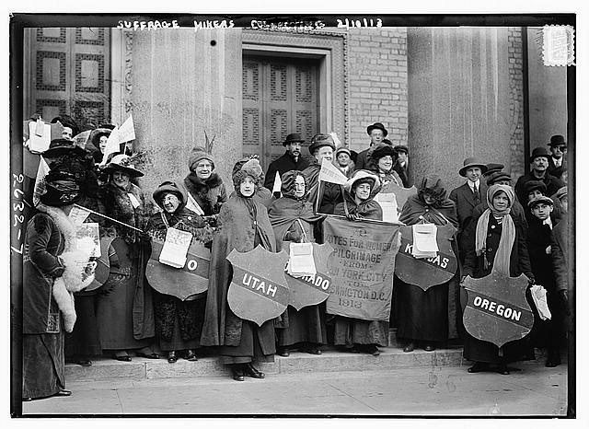
Suffrage Hikers. Courtesy of Library of Congress.
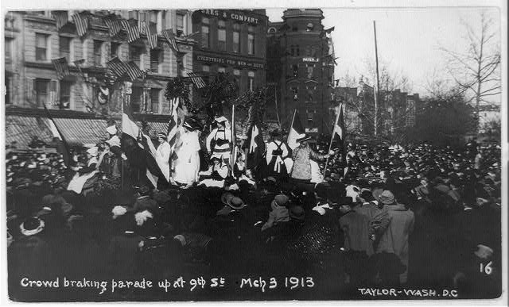
Crowd breaking up the parade. Courtesy of Library of Congress.

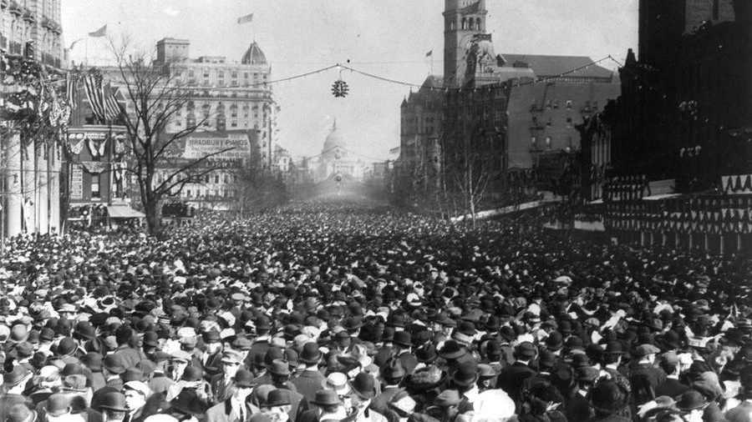
Crowds at the 1913 parade. Courtesy of Library of Congress.

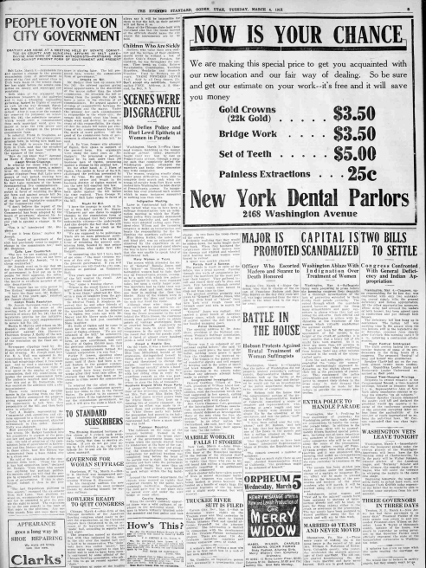
The Evening Standard, Ogden, Utah, March 4, 1913

SCENES WERE DISGRACEFUL
Mob Defies Police and Hurl Epithets at Women in Parade

Washington, March 3--Five thousand women marching in the woman suffrage pageant today, practically fought their way foot by foot up Pennsylvania avenue, through a surging mob that completely defied the Washington police, swamped the marchers and broke their procession into little companies.
The women trudging stoutly along under great difficulties were able to complete their march only when the troops of cavalry from Fort Meyer were rushed into Washington to take charge of Pennsylvania avenue. No inauguration has ever produced such scenes which in many instances amounted to nothing less than riots.

Indignation Meeting.
Later in Continental hall the women turned what was to have been a suffrage demonstration into an indignation meeting in which the Washington police were roundly denounced for their inactivity, and resolutions were adopted calling upon President-elect Wilson and the incoming congress to make an investigation and locate the responsibility for the indignities the marchers suffered.
Miss Helen Keller, the noted blind and deaf girl, was so exhausted and unnerved by the experience in attempting to reach a grand stand where she was to have been a guest of honor that she was unable to speak at Continental hall.

Many Women in Tears.
The scenes which attended the entry of “General” Rosalie Jones and her “hikers” on Thursday, when the bedraggled women had to fight their way up Pennsylvania avenue, swamped by a mob with which few policemen struggled in vain, were repeated today, but upon a vastly larger scale. The marchers had to fight their way from the start and took more than one hour in making the first ten blocks. Many of the women were in tears under the jibes and insults of the mob that lined the route.
Although stout wire ropes had been stretched up and down the entire length of Pennsylvania avenue from the Peace monument to the mall behind the White House, the enormous crowds that gathered early to obtain points of vantage overstepped them or crawled beneath. Apparently no effort was made to drive back the trespassers in the early hours, with the result that when the parade started it faced at almost every hundred yards a solid wall of humanity.

Crowd a Hostile One.
On the whole, it was a hostile crowd through which the women marched. Miss Inez Milholland, herald of the procession, distinguished herself by riding down a mob that blocked the way and threatened to disrupt the parade. Another woman member of the “petticoat cavalry” struck a hoodlum a stinging blow across the face with her riding crop in reply to a scurrilous remark as she was passing. The mounted police seemed powerless to stem the tide of humanity.

Hoodlums Disgust White House Party.
A group of hoodlums gathered in front of the reviewing stand, in which sat Mrs. Taft and Miss Helen Taft, and a half dozen invited guests from the White House. They kept up a running fire of caustic comment. Apparently no effort was made to remove them, and evidently disgusted, the White House party left before the procession had passed in its halting and interrupted journey toward Continental hall, where a mass meeting was held.

Tableaux Beautiful.
The tableaux on the steps of the treasury building, framed in the great columns and the broad stairway of the government house, were begun when the parade started from its rendezvous at the base of the capitol. Beautiful in its color and grouping, the dramatizations of women’s aspirations for political freedom was completed long before the head of the parade was in sight. In their thin dresses and bare arms the performers waiting, shivering for more than an hour until finally they were forced to seek refuge within the big building.
Around the treasury department the crowds were massed so tightly that repeated charges by the police were seemingly ineffective. Occasionally the mob gave way in one place only to break over and under the wire hedge at some other.

Cavalry Appears.
When the cavalry suddenly appeared there was a wild outburst of applause in the reviewing stand. The men in brown virtually brushed aside the mounted and foot police and took charge. In two lines the troops charged the crowds.
Evidently realizing that they would be ridden down, the mobs fought their way back. When they hesitated the cavalrymen drove their horses into the throngs and whirled and wheeled until hooting men and women were forced to retreat.
A space was quickly cleared.

Parade Itself a Success.
The parade in itself, in spite of the delays, was a great success. Passing through two walls of antagonistic humanity the marchers for the most part kept their temper. They suffered insult and closed their ears to jibes and jeers. Few faltered, although several of the older women were forced to drop out from time to time.
The greatest ovation was probably given to “General” Rosalie Jones, who led her little band of “hikers” from New York over rough roads and through snow and rain to march for the cause.
“General” Jones was radiant. She carried a bunch of American Beauty roses, which made a splash of scarlet against the dull brown of her hooded tramping gown.

Police Denounced.
The opening address by Dr. Anna Howard Shaw, president of the National American Woman’s Suffrage association, was a bitter excoriation of the police.
“Never was I so ashamed of our nation’s capital before,” she said. “If anything could prove the need of the ballot, nothing could prove it more than the treatment we received today. The women in the parade showing wonderful dignity and self respect by keeping cool in the midst of insult and lewd remarks. Hoodlums were given freedom in the streets today without any adequate attempt being made to protect us.”

Congressional Investigation.
Oswald Garrison Villard, grandson of William Lloyd Garrison, at the conclusion of Dr. Shaw’s address, read the resolution which she had suggested in her speech, calling for congressional investigation and it was adopted with wild cheers.
Mrs. Carrie Chapman Catt, president of the International Suffrage association, declared that members of congress should demand an investigation. Many of the men along the line, she declared, “were drunk enough for the lockup.” In no other nation but Switzerland, she said, have the women been forced to take their appeal for vote “to the rabble.”

