The following is an excerpt from a petition by Angie F. Newman to U.S. Congress in June 1886. Newman was a national anti-polygamist leader from Nebraska who visited Utah in 1880 as the secretary of the Woman’s Home Missionary Society. This society sought to build a home for women who wanted to escape polygamous marriage and be self-sufficient. She traveled around the country, giving anti-polygamist lectures and raising money to build this home. She later testified before Congress about the “Mormon problem.”

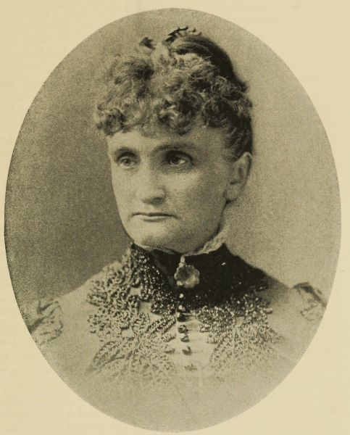
“A man with half a dozen wives would now have half a dozen votes besides his own.”

“They [Utah women] were never enfranchised by the Federal Government, or by any branch of it, or by its representative. They were enfranchised by a church organization in which the authority of the Federal Government was not recognized even as a factor. They were enfranchised for church ends alone to make the church impregnable [not likely to be weakened] to outward attack…”

“Withdraw this ‘mighty power’ [voting rights] in elections--of 12,000 female votes--and very soon county and municipal Gentile [non-Mormon] officers could be elected and Gentile representatives chosen for the legislature. . . . The centers of Gentile representation are the mining districts. Most of the miners are unmarried men, or men who have left their families in the East. The vote of the Mormon women nullifies [has no legal power] Gentile political power in these districts. Gentile women rarely vote in any part of the territory. First, because their ballot signifies nothing; it is labor lost. Second, the general exercise of the ballot in the Territory is such a travesty upon all that is sacred to woman that Christian motherhood refuses to be compromised by recognition of the nefarious [evil or immoral] scheme.”

Excerpt from “Woman Suffrage in Utah,” Petition of Angie F. Newman to U.S. Congress, June 8, 1886.

- What biases may Angie Newman have had about Mormon women? How do these biases influence your thoughts on the validity of her arguments?

- What arguments does Newman make for disfranchising Utah women (taking away their voting rights)? Do you agree or disagree with her reasoning? Why or why not?

- Newman uses many strong words to make her point. Do you think they help or hurt her arguments? Why or why not?

- What is the “nefarious scheme” to which Newman refers?

- Why do you think Newman and other anti-polygamists were in favor of taking away Utah women’s voting rights?

